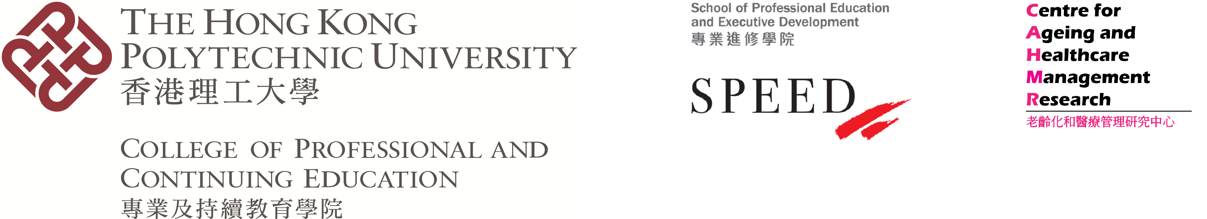

CPCE Health Conference 2022
10 January 2022

Long-term Care: Financing and Service Delivery in Asia-Pacific

Call for Papers

Ageing population is a worldwide issue and an increase in the number of older people is associated with an increasing need for long-term care. Financing long-term care and the associated service delivery are critical issues to the community and the health professionals.

The objective of the 7th Annual CPCE Health Conference 2022 is to explore the emerging policy, practices and management of long-term care in financing and service delivery. Against this background, the Conference Organiser invites submissions on (but not limited to) the following sub-themes:
- Application of technology in health and long-term care
- Community-based programmes
- District health and its effectiveness
- Healthy ageing and public/social policy
- Innovative healthcare management strategies in health institutions and the community
- Manpower of health and long-term care
- Monitoring psychological health for older adults
- Patient and staff safety during the pandemic
- Quality assurance in health services for older adults
- Social responsibility of health care service organisations
Notes to Authors

Please submit an abstract of 350 to 500 words, and/or a full paper, in English, by 31 December 2021 to callforpaper-healthconf2022@cpce-polyu.edu.hk. Abstracts and/or full papers submitted to this Conference should not have been previously published or under review in any journals. The Conference Organiser will select papers for presentation on a competitive basis. Notification of abstracts and/or full papers acceptance for presentation will be provided within four weeks after the submission deadline. The accepted author(s) should prepare a 15-minute PowerPoint presentation in English. The oral presentation should be in English. Full papers, subject to a double-blind review process, will be considered for potential publication in a special issue or a regular issue with the Public Administration and Policy: an Asia-Pacific Journal and Asia-Pacific Journal of Health Management.

In addition, there will be a parallel session for presentation of papers in English by students of tertiary institutions. Students from local and overseas institutions are welcome.

You are reminded to register for the Conference via the official website: http://healthconf2022.cpce-polyu.edu.hk/

Enquiries on submission of papers, including full papers intended for the two Journals, can be directed to: callforpaper-healthconf2022@cpce-polyu.edu.hk

Abstract (template)

[Title of the Paper]
John T. M. Chanª*, Sam M. Writer^{b}
ª School of Professional Education and Executive Development, The Hong Kong Polytechnic University, Hong Kong
^{b} College of Professional and Continuing Education, The Hong Kong Polytechnic University, Hong Kong

*Corresponding author: Dr. John T. M. Chan (chantaiman@speed-polyu.edu.hk)

Abstract

